

AAVISHKAR INSTITUTE

DEVELOPED BY: TANU SHAMRA

CHAPTER**:**1

Introduction & Object of Project

Introduction

This project is specially designed for Students, because in this project students can take online Admission from Aavishkar Institute from their home which is registered in this project. Students can apply for admission through our project “Aavishkar Institute”.

The “Aavishkar Institute” project is a multi-user system. It has been developed in a way that allows user to perform the function smoothly and with proper accuracy.

The system is developed in PHP, My-SQL, Java script and CSS for designing purpose.

So, this system is very useful for all students.

How It Works?

In this project first of all a homepage is displayed for all visitors as well as registered students/users.

If user wants to take admission, then they have to Login first. If the user is not a Registered User, he/she will have to click on the Signup Button and fill all the fields in the registration form.

After registering you can see login page. Users will have to login with their registered mobile number and password.

After login, user will see User-Panel of ‘Aavishkar Institute’ Website. User can simply apply for admission by filling all the required details.

CHAPTER**:**2

Tools or Platform

Requirement Details

* Software:
* XAMPP Server
* Any browser like Google Chrome, Internet Explorer, etc.
* Hardware:
* Processor: Intel Core i3
* RAM: 8.00 GB
* Hard Disk: 1.00 TB
* Tools Used:
* Front End: HTML, CSS, JavaScript
* Back End: PHP
* Operating System: Windows 10

CHAPTER**:**3

System Analysis

3.1 Identification of Needs

3.2 Preliminary Investigation

3.3 Feasibility Study

3.4 Project Planning

3.5 Project Scheduling (PERT Chart and GANTT Chart)

3.6 Software Requirement Specification

3.7 Data Models

3.1 Identification of Needs

The viewer of our system does not need to login as long as User wants to browse information about Aavishkar Institute only. But if the User wants to apply for admission in Aavishkar Institute, then he/she must be registered to our website.

User needs to provide first name, last name, email, mobile number and password when creating an account.

SDLC Model

Planning

Analysis

Coding

Designing

Testing

Implementation & Maintenance

SDLC Steps

* Step 1: Requirement Gathering

In this phase of SDLC necessary information are collected. We collect the information in this phase through questionnaire and online websites also. We also note down the requirements of the User.

* Step 2: Requirement Specification & Analysis

The requirements are being specified in this phase. Analyst checks how the current system is working and then plans how to develop the proposed system and implement it.

* Step 3: Design

In this phase the design of both front-end and back-end is decided. In this phase we use HTML, CSS for designing, and designing of tables are also done properly in this phase.

* Step 4: Coding

After the completion of designing there is a turn for coding. Coding is completed in various files. In most of the cases coding takes much more time than designing.

* Step 5: Testing

In testing phase first unit level testing is done. In unit level testing the software is tested in an individual file. After the unit testing of each file, the integration testing done. In integration testing the files are tested into their own package. At last, in the system testing the whole system is run on the Internet Environment.

* Step 6: Maintenance

The proper maintenance is given as indicated in the SRS (Software Requirement Specification). It is a responsibility of Developer to maintain the software during its criteria mentioned in SRS document.

3.2 Preliminary Investigation

* Our Objectives
* Admin can Add, Delete and Edit records.
* User can learn about various courses.
* User can handle all type of information easily.
* User can contact us at any time, for any query.
* Easy updating, time saving, quick process.
* User can update their sign-up details.
* User can get simply apply for admission by filling the admission form.

* Platform Specification

We have used windows based developing & graphical based applications; our software will provide support for GUI efficiently. It is must for our system because for our project.

It is very useful and supportive for PHP and Java Script to control the components. There is use of CSS for menu creation and display web page in it. It’s easy to use integrity database report with Data Report.

PHP platform is mostly use for developing web-based application, regular version of operating system is used with it. Always need the back-end tool for developing web application with front-end tool.

When starting a new business, organizations have some requirement for it. There are many reasons for starting a new business or modify the old system.

Business requirement set depends on the top-level organization i.e., manager, administrator etc.

3.3 Feasibility Study

A feasibility analysis usually involves a thorough assessment of the operational(need), financial and technical aspects of a proposal.

Feasibility study is the test of the system proposal made to identify whether the user needs may be satisfied using the current software and hardware technologies, whether the system will be cost effective from a business point of view and whether it can be developed with the given budgetary constraints.

A feasibility study should be relatively cheap and done at the earliest possible time.

Depending on the study, the decision is made whether to go ahead with a more detailed analysis.

When a new project is proposed, it normally goes through feasibility assessment.

Feasibility study is carried out to determine whether the proposed system is possible to develop with available resources and what should be the cost consideration.

Facts considered in the feasibility analysis are:

1. Technical Feasibility

Technical feasibility is considered in terms of technical requirements and their availability in the market. It determines whether the current level of technology supports the proposed system or not. The technical possibility of proposed system is as follows:

* The unit does possess the hardware as well as related software for the project.
* The proposed system does not require much technical detail. It just requires window operating system.
* The organization has already purchased all the enough devices for latest technical specifications.
* These technical specifications are easily available in the market.

Hence, the proposed system is technically feasible.

1. Economical Feasibility Study

Economic justification is generally the “Bottom Line” consideration for most systems. It includes a broad range of concerns that includes cost benefit analysis.

In this, we weight the cost and the benefits associated with the candidate system and if it suits the basic purpose of the organization, i.e., profit making, the project is making to the analysis and design phase.

The financial and the economic questions during the preliminary investigation are verified to estimate the following:

* The cost to conduct a full system investigation.
* The cost of hardware and software for the class of application being considered.
* The benefits in the form of reduced cost.
* The proposed system will give the minute information, as a result the performance is improved which in turn may be expected to provide increased profits.

This feasibility checks whether the system can be developed with the available funds. This can be done economically if planned judicially, so it is economically feasible. The cost of project depends upon the number of man hours required.

1. Operational Feasibility Study

It is mainly related to human organizations and political aspects. The points to be considered are:

* What changes will be brought with the system?
* What organization structures are disturbed?
* What new skills will be required?
* Do the existing staff members have these skills? If not, can they be trained in due course of time?

The system is operationally feasible as it very easy for the and users to operate it. It only needs basic information about Windows platform.

3.4 Project Planning

|  |  |  |  |  |
| --- | --- | --- | --- | --- |
| No. | Task Name | Start | Finish | Duration |
| 1 | Planning | 18/06/2022 | 30/06/2022 | 1.6 Week |
| 2 | Analysis | 01/07/2022 | 18/07/2022 | 2.4 Week |
| 3 | Designing | 19/07/2022 | 31/07/2022 | 1.6 Week |
| 4 | Coding | 01/08/2022 | 25/08/2022 | 3.4 Week |
| 5 | Implementation | 26/08/2022 | 04/09/2022 | 1.3 Week |
| 6 | Testing | 05/09/2022 | 15/09/2022 | 1.4 Week |
| Total = 90 Days | | | | |

3.5 Project Scheduling

* Pert Chart

This chart represents the development of our system date wise.

Planning

18/06/2022

Analysis

01/07/2022

Designing

19/07/2022

Coding

01/08/2022

Implementation

26/08/2022

Testing

05/09/2022

Finish

15/09/2022

* Gantt Chart

This is a graphical representation of the date wise development of our project system. It is very similar to the PERT chart except that it is represented graphically.

ID

Task Name

June 22

July 22

1

2

3

Planning

Analysis

4

5

6

Designing

Coding

Implementation

Testing

18 June – 30 June

01 July - 18 July

19 July - 31 July

01 Aug - 25 Aug

26 Aug - 04 Sep

05 Sep - 15 Sep

Aug 22

Sept 22

3.6 Software Requirement

* PHP

PHP is a widely-used general-purpose scripting language that is especially suited for Web development and can be embedded into HTML. It generally runs on a web server, taking PHP code as its input and creating Web pages as output. However, it can also be used for command-line scripting and client-side GUI applications.

PHP can be deployed on most web servers and on almost every operating system and platform free of charge.

PHP Group also provides the complete source code for users to build, customize and extend for their own use.

PHP primarily acts as a filter. The PHP program takes input from a file or stream containing text and special PHP instructions and outputs another stream of data for display.

From PHP 4, the PHP parser compiles input to produce byte code for processing by the Send Engine, giving improved performance over its interpreter predecessor. PHP 5 uses the Send Engine II. Originally designed to create dynamic web pages, PHP's principal focus is server-side scripting.

* My SQL
* MySQL is a database management system:

A database is a structured collection of data. It may be anything from a simple shopping list to a picture gallery or the vast amounts of information in a corporate network. To add, access, and process data stored in a computer database, you need a database management system such as MySQL Server.

Since computers are very good at handling large amounts of data, database management systems play a central role in computing, as standalone utilities, or as parts of other applications.

* MySQL software is Open Source:

Open-Source means that it is possible for anyone to use and modify the software. Anybody can download the MySQL software from the Internet and use it without paying anything. If you wish, you may study the source code and change it to suit your needs.

The MySQL software uses the GPL (GNU General Public License), http://www.fsf.org/licenses/, to define what you may and may not do with the software in different situations. If you feel uncomfortable with the GPL or need to embed MySQL code into a commercial application, you can buy a commercially licensed version from us. The MySQL Database Server is very fast, reliable, scalable, and easy to use. MySQL Server works in client/server or embedded systems.

* MySQL databases are relational:

A relational database stores data in separate tables rather than

putting all the data in one big storeroom. The database structures are organized into physical files optimized for speed. The logical model, with objects such as databases, tables, views, rows, and columns, offers a flexible programming environment.

You set up rules governing the relationships between different data fields, such as one-to-one, one-to-many, unique, required or optional, and “pointers” between different tables. The database enforces these rules, so that with a well-designed database, your application never sees inconsistent, duplicate, orphan, out-of-date, or missing data.

The SQL part of “MySQL” stands for “Structured Query Language”. SQL is the most common standardized language used to access databases.

Depending on your programming environment, you might enter SQL directly (for example, to generate reports), embed SQL statements into code written in another language, or use a language-specific API that hides the SQL syntax.

SQL is defined by the ANSI/ISO SQL Standard. The SQL standard has been evolving since 1986 and several versions exist.

* Java Script
* JavaScript Origins:

JavaScript was released by Netscape and Sun Microsystems in 1995. However, JavaScript is not the same thing as Java.

* It is a programming language.
* It is an interpreted language.
* It is object-based programming.
* It is widely used and supported.
* It is accessible to the beginner.
* Uses of JavaScript:

Use it to add multimedia elements With JavaScript you can show, hide, change, resize images, and create image rollovers. You can create scrolling text across the status bar.

Create pages dynamically Based on the user's choices, the date, or other external data, JavaScript can produce pages that are customized to the user.

* HTML

HTML is the standard Mark-up language for creating web pages and CSS and JavaScript it forms a triad of cornerstone technologies for the WWW.

Web browsers receive HTML documents from a web server or from local storage and render them into multimedia web pages.

HTML describes the structure of a web page semantically and originally included cues for the appearance of the document.

Hyper Text Mark-up Language (HTML) can embed programs written in a scripting language such as JavaScript which affect the behavior and content of web pages.

Inclusion of CSS defines the look and layout of content. The World Wide Web Consortium (W3C), maintainer of both the HTML and the CSS standards, has encouraged the use of CSS over explicit presentational HTML since 1997.

* CSS

Cascading Style Sheet (CSS) is a Style sheet language used for describing the presentation of a document written in a Mark-up language.

Although most often used to set the visual style of web pages and user interfaces written in HTML and XHTML, the language can be applied to any XML document, including plain XML, SVG and XUL, and is applicable to rendering in speech, or on other media.

Along with HTML and JavaScript, CSS is a cornerstone technology used by most websites to create visually engaging web pages, user interfaces for web applications, and user interfaces for many mobile applications.

CSS is designed primarily to enable the separation of presentation and content, including aspects such as the layout, colors, and fonts.

3.7 Data Models

* Data Flow Diagram

1. 0-Level Visitor Data Flow Diagram:

User

Aavishkar Institute

Home

About Us

Courses

Admission

Sign Up

Login

Contact Us

No

Yes

1. 0-Level User Data Flow Diagram:

Aavishkar Institute

Home

Courses

Admission

Feedback

Login

Messages

No

Yes

User

Student Query

Leave Application

Change Password

Profile

1. 0-Level Admin Data Flow Diagram:

No

Yes

Login

Aavishkar Institute

Manage Admissions

Remove User

Send Message

Manage Student Query

Manage Feedback

Manage Courses

Contact Us

Manage Leave Application

Change Password

Admin

Profile

Home

1. 1-Level Visitor Data Flow Diagram:

Aavishkar Institute

Home

Admission

About Us

Courses

Login

contactus

user_login

Sign Up

Contact Us

admission

courses

1. 1-Level User Data Flow Diagram:

Aavishkar Institute

Home

Admission

Messages

Stud Query

Leave Application

Feedback

Profile

Change Password

admission

courses

messages

studquery

lv_app

feedback

user_login

Logout

Courses

user_login

1. 1-Level Admin Data Flow Diagram:

Home

Aavishkar Institute

admission

courses

user_ login

messages

studquery

lv_app

contactus

Manage Admissions

Send Message

Manage Stud Query

Manage Leave Application

Contact Us

Profile

Change Password

Logout

Manage Courses

Manage Users

Manage Feedback

feedback

user_login

user_login

1. 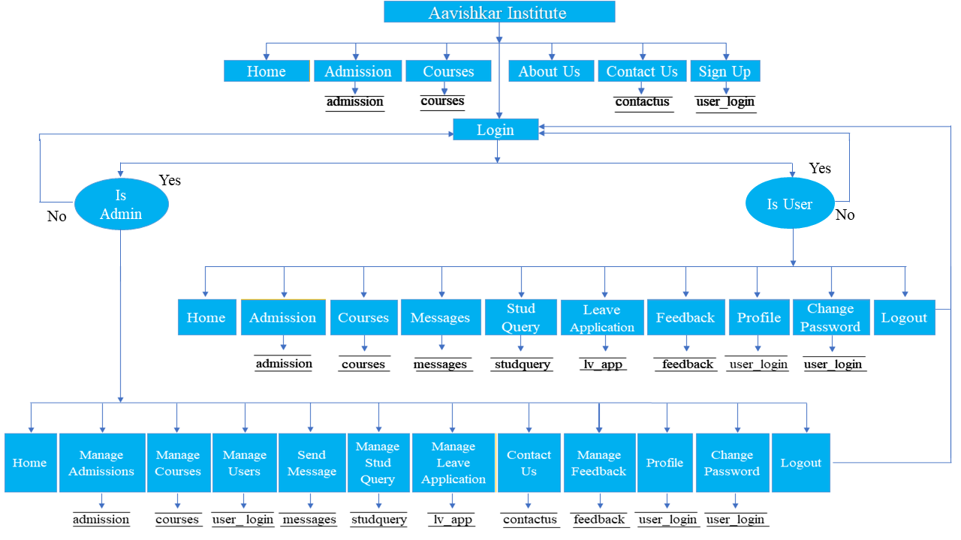Context-Level Visitor, User, Admin Data Flow Diagram:

* ER Diagram

admission

courses

* Use Case Diagram

1. Visitor Use Case Diagram:

Home

Admission

About Us

Courses

Login

Contact Us

Sign Up



1. User Use Case Diagram:

Home

Admission

Messages

Courses

Profile

Leave Application

Feedback

Change Password



Logout

Student Query

1. Admin Use Case Diagram:

Manage Admissions

Manage Courses

Send Message

View / Remove User

Contact Us

Manage Stud Query

Manage Leave Application



Manage Feedback

Logout

Profile

Change Password

Home

* Activity Diagram

User Login

Home

Yes

Apply for Admission

If click

Process for Admission

Admission Confirmed

Yes

Receive Message

Return to Home

No

No

No

No

3.8 Normalization

* Normalization rules are divided into following normal forms:

1. First Normal Form (1NF)

As per First Normal Form, no two rows of data can contain repeating group of information id, each set of columns must have a unique value, such that multiple columns cannot be used to fetch the same row. Each table should be organized into rows, and each row should have a primary key that distinguishes it as unique.

The Primary key is usually a single column, but sometimes more than one column can be combined to create a single primary key. For example, consider a table which is not in First normal form.

1. Second Normal Form (2NF)

As per the Second Normal Form there must not be any partial dependency of any column on primary key. It means that for a table that has concatenated primary key, each column in the table that is not part of the primary key must depend upon the entire concatenated key for its existence. If any column depends only on one part of the concatenated key, then the table fails Second normal form.

In User Table the candidate key will be column. Now, both the above tables qualify for Second Normal Form and will never suffer from update anomalies. Although there are a few complex cases in which table in Second Normal Form suffers update anomalies, and to handle those scenarios Third Normal Form is there.

1. Third Normal Form (3NF)

Third Normal form applies that every non-prime attribute of table must be dependent on primary key, or we can say that, there should not be the case that a non-prime attribute is determined by another non-prime attribute. So, this transitive functional dependency should be removed from the table and also the table must be in Second Normal form. For example, consider a table with following fields.

In this table User id is Primary key, but first name, last name and email depends upon mobile. The dependency between mobile and other fields is called transitive dependency. Hence to apply 3NF, we need to move the first name, last name and email to new table with mobile as primary key.

The advantage of removing transitive dependency is:

* Amount of data duplication is reduced.
* Data integrity is achieved.

CHAPTER**:**4

System Design

4.1 Tables Detail

4.2 Database Structure

4.3 Visitor Interface

4.4 User Interface

4.5 Admin Interface

4.6 Source Code

4.1 Tables Detail

* Visitor Side Table:

1. user_login

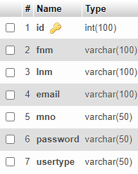

1. courses

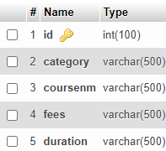

1. contactus

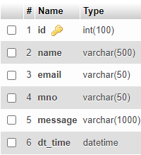

* User Side Table:

1. user_login



1. courses



1. admission

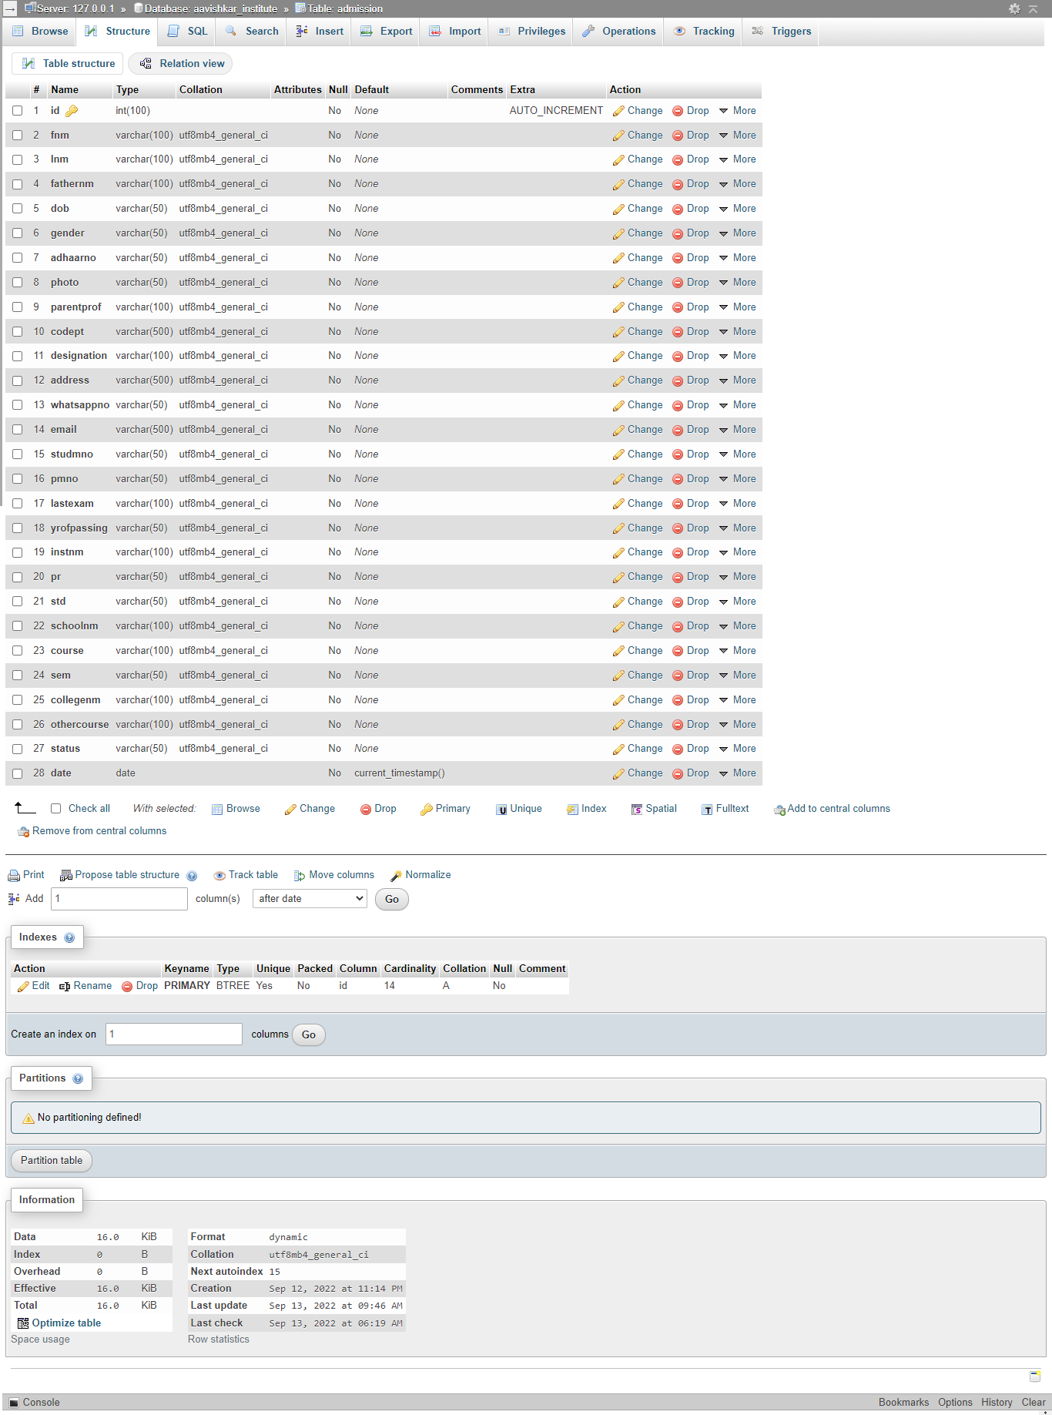

1. studquery

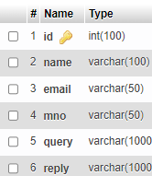

1. lv_app

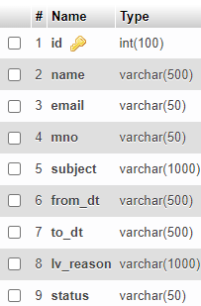

1. messages

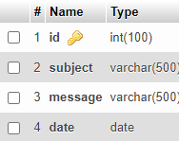

1. feedback

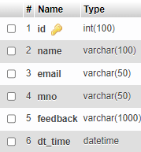

* Admin Side Table:

1. user_login



1. courses



1. admission



1. messages



1. studquery



1. lv_app



1. contactus



8. feedback



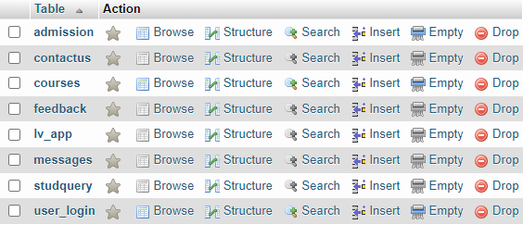

4.2 Database Structure

4.3 Visitor Interface

1. 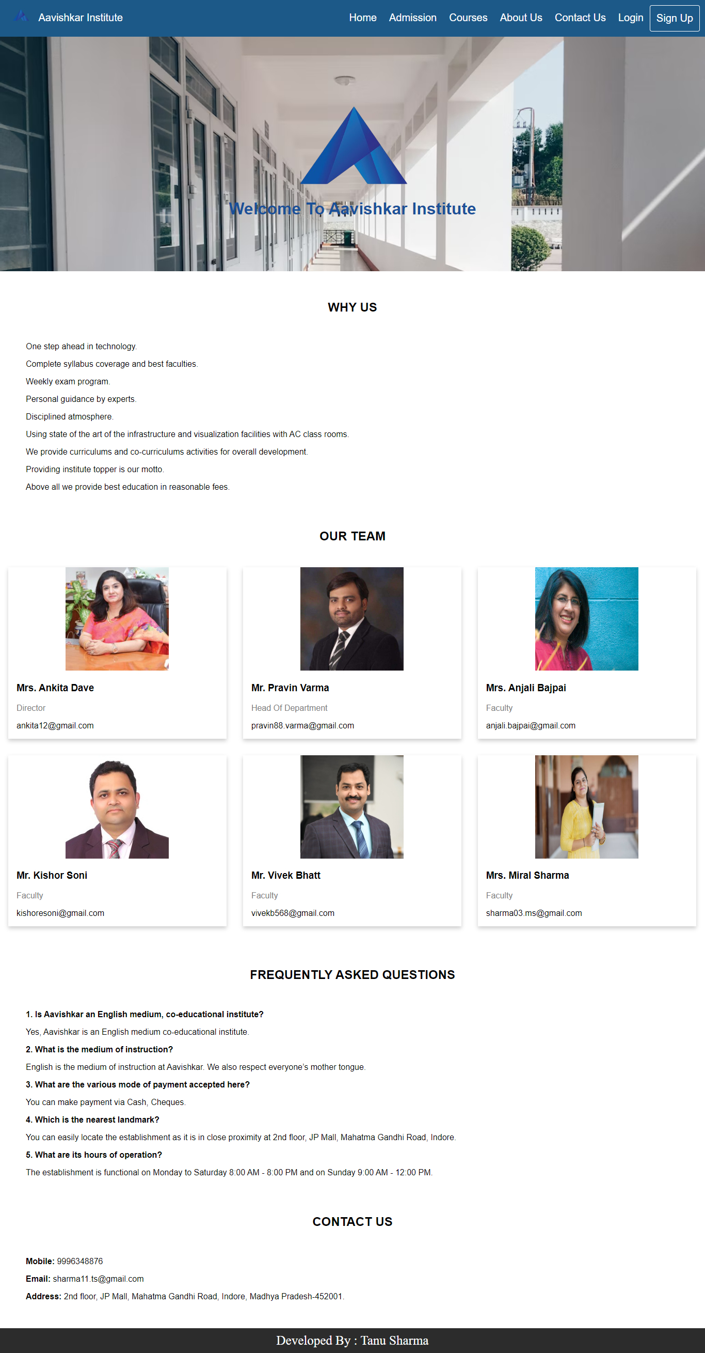Home Page: This is home page for visitor.
2. 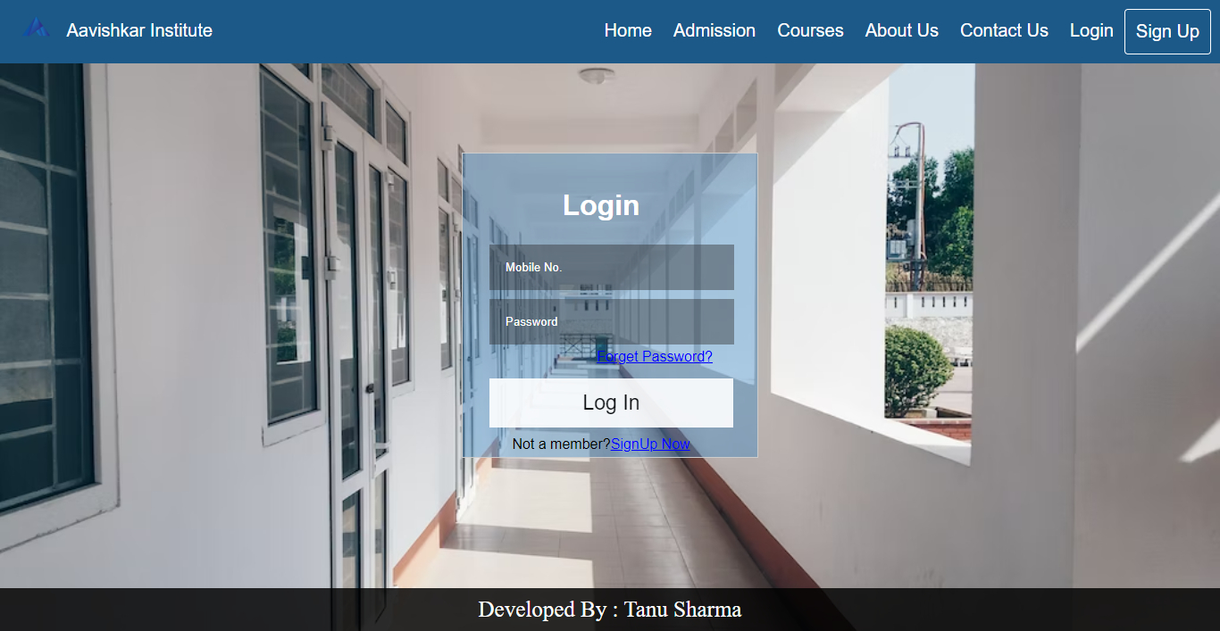Admission Page: User must login to apply for admission.
3. Courses Page: Visitor can see courses information.

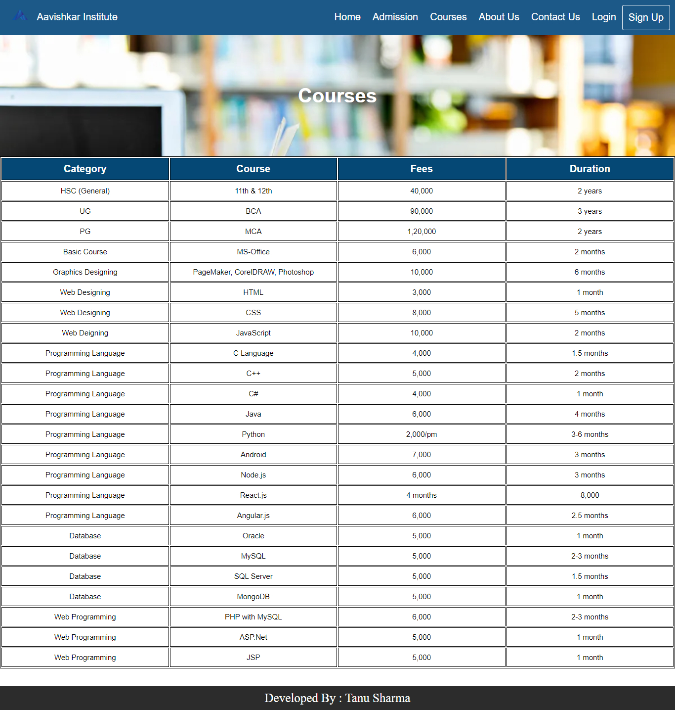

1. About Us Page: This page describes about “Aavishkar 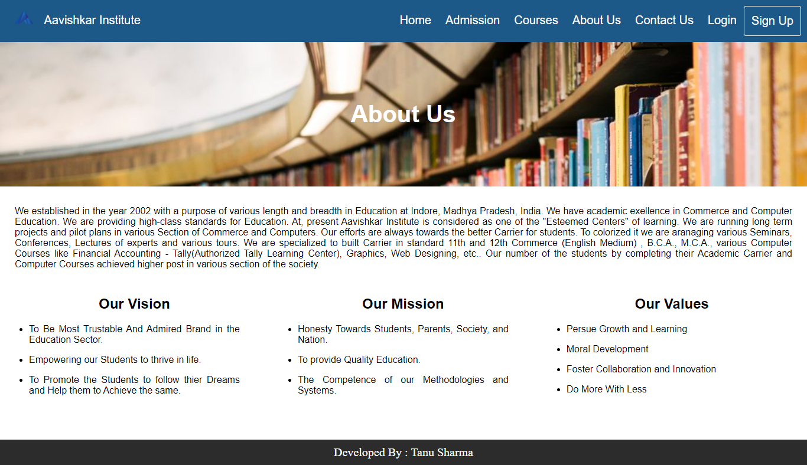Institute”.
2. 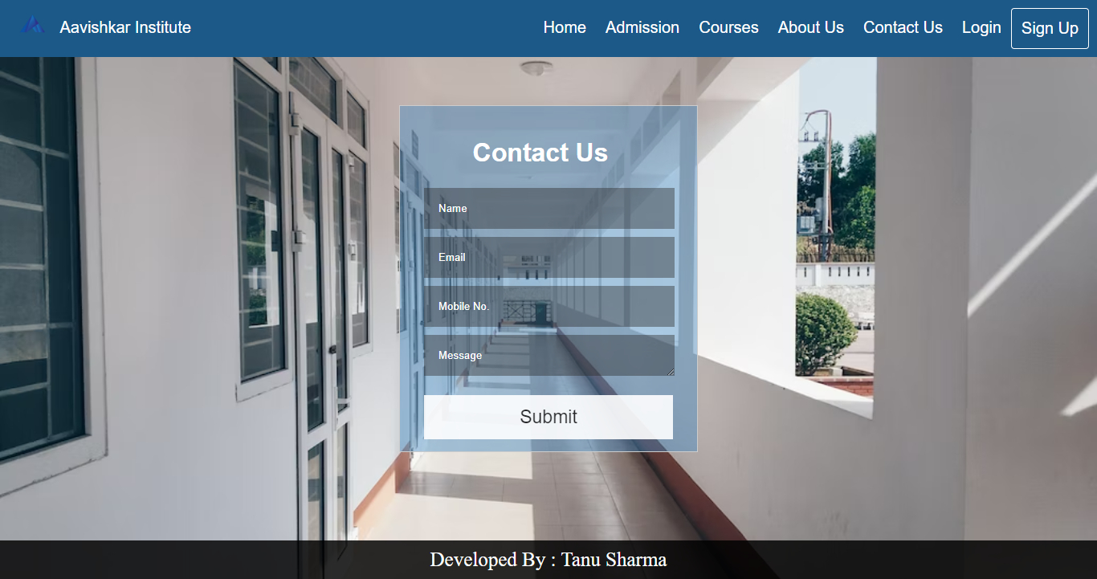Contact Us Page: Visitor can contact the institute.
3. Login Page: Existing user can simply login with his mobile no. and password.
4. 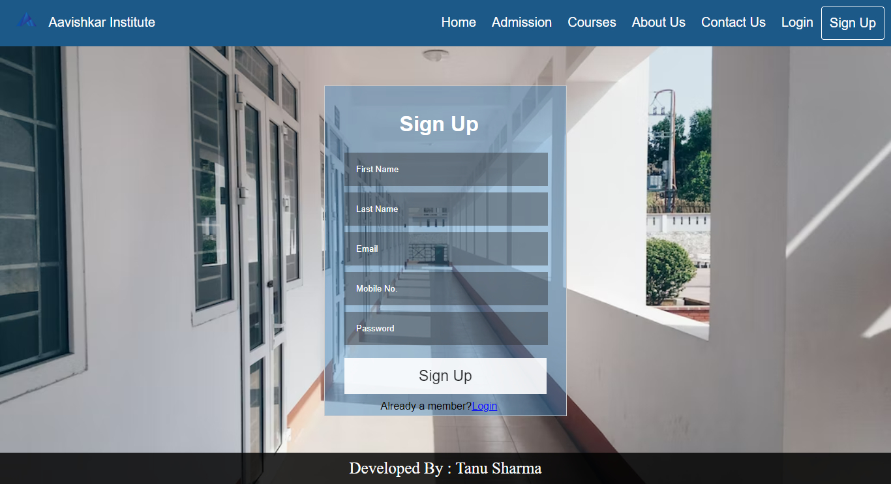Sign Up Page: New user can simply sign up by providing required details.

4.4 User Interface

1. 

1. Home Page: After user login, a home page is displayed.

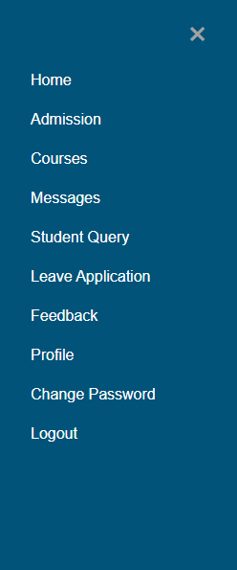On header ,there’s a menu button. User can open it and go to the particular page.

1. 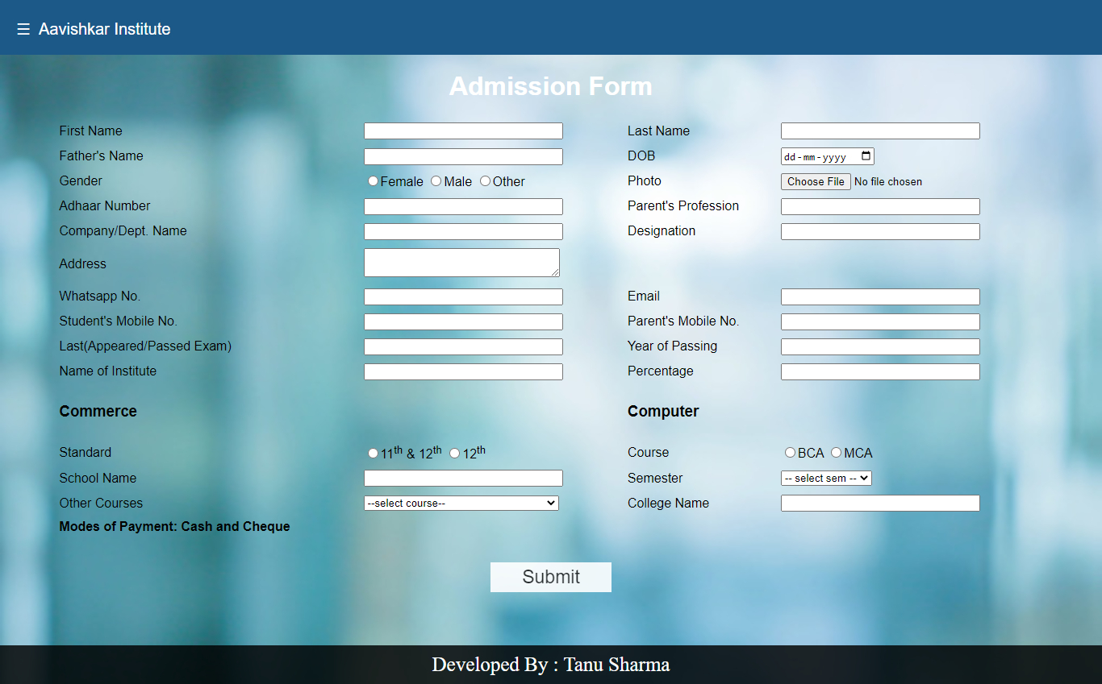Admission Page: Here user can apply for admission.
2. Courses Page: User can see courses information.

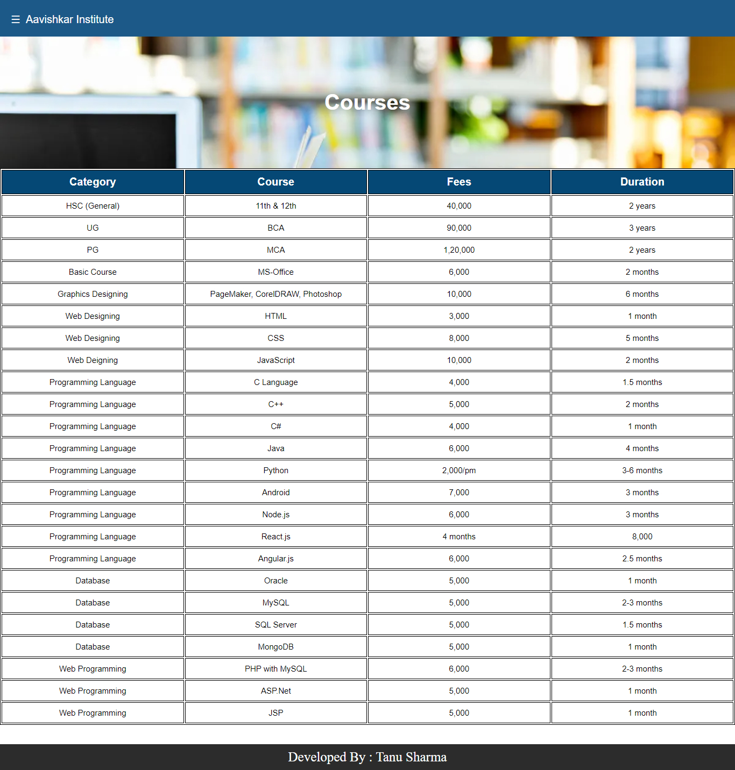

1. 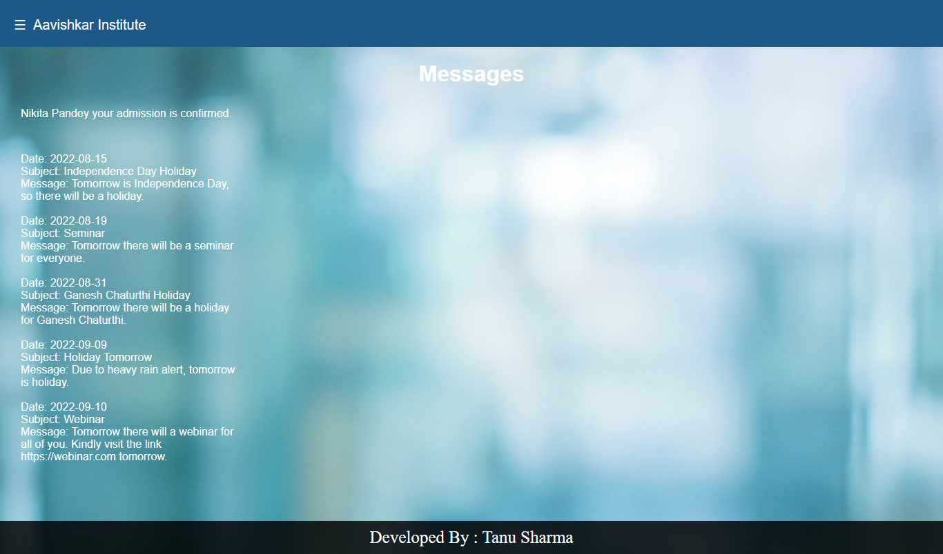Messages Page: Students can see messages send by admin.
2. Student Query Page: Here students can ask their queries.

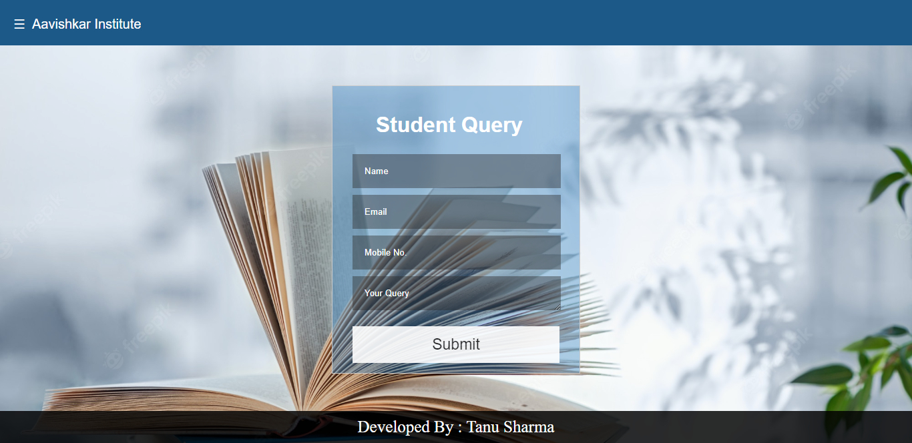

1. 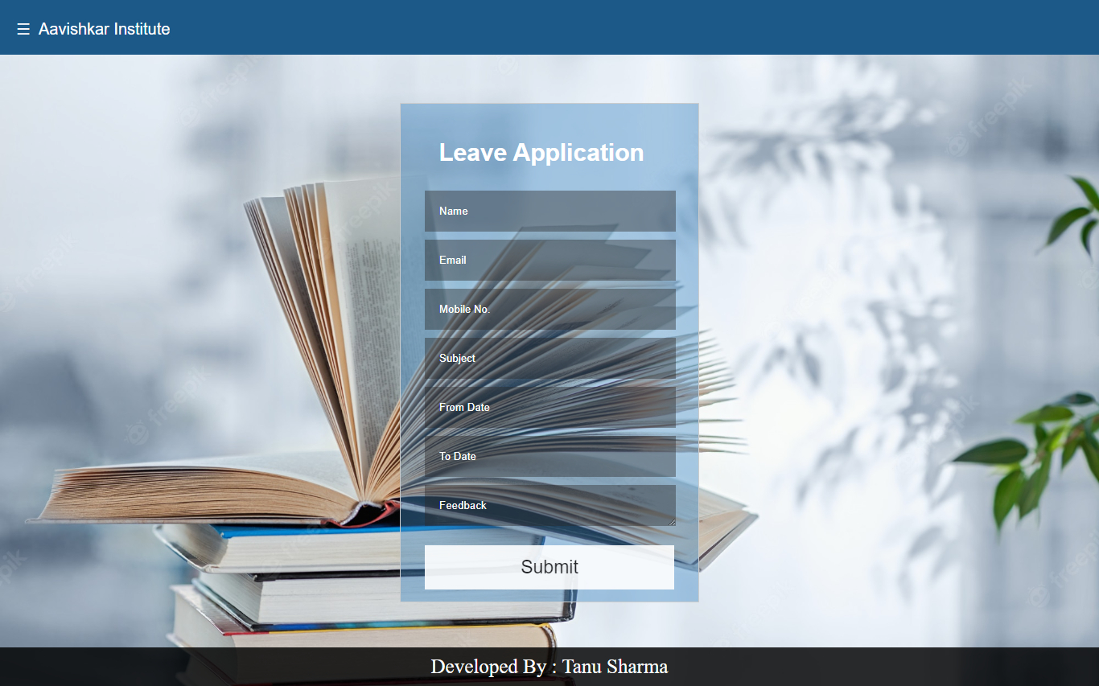Leave Application Page: Here students can apply for leave.
2. 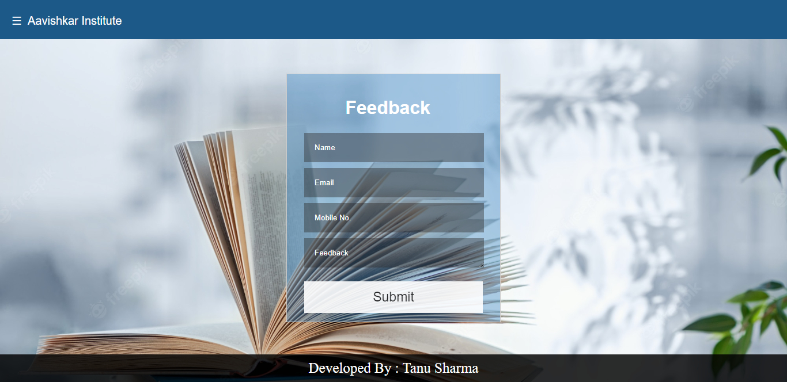Feedback Page: Here user can give their feedback.
3. 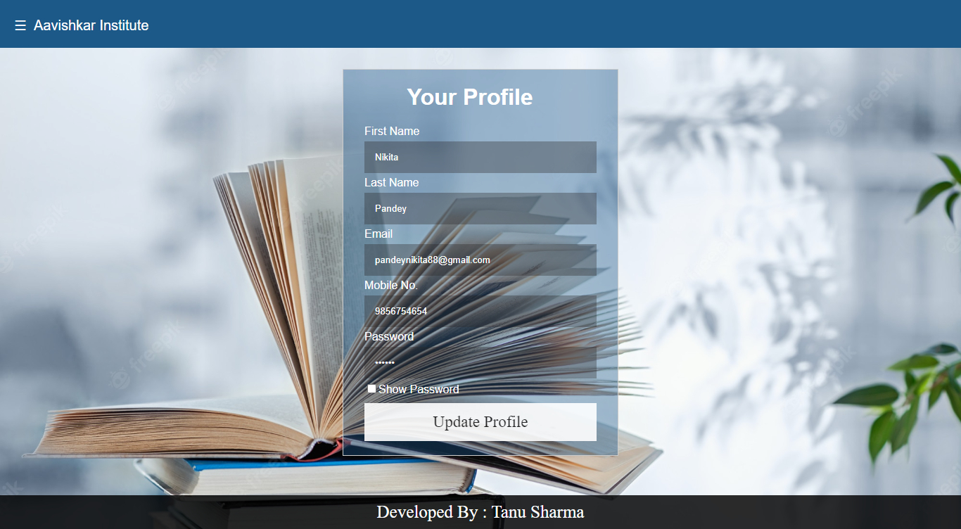Profile Page: Here user can see and update his profile.
4. 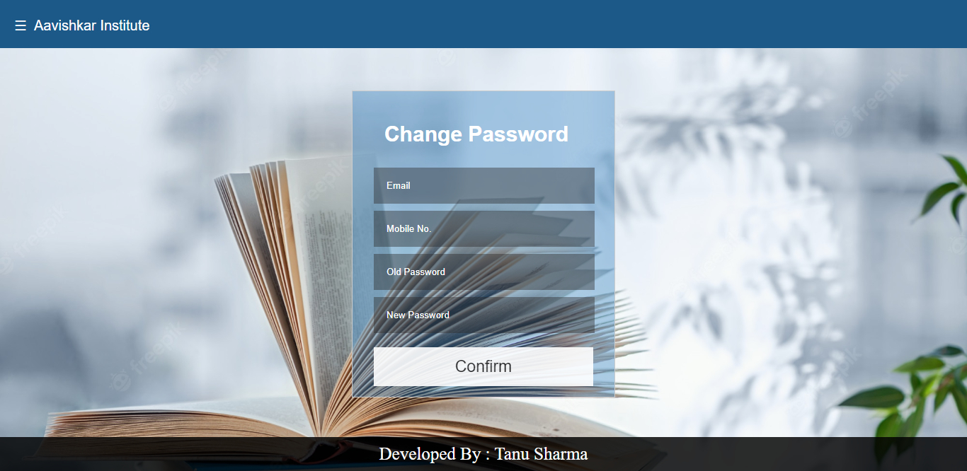Change Password Page: Here user can easily change password.

4.4 Admin Interface

1. Home Page: After admin login, a home page is displayed.

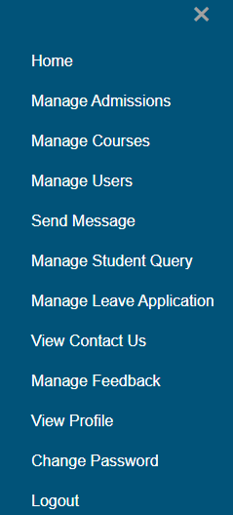On header ,there’s a menu button. Admin can open it and go to the particular page.

1. Admission Page: Here admin can add new student and confirm 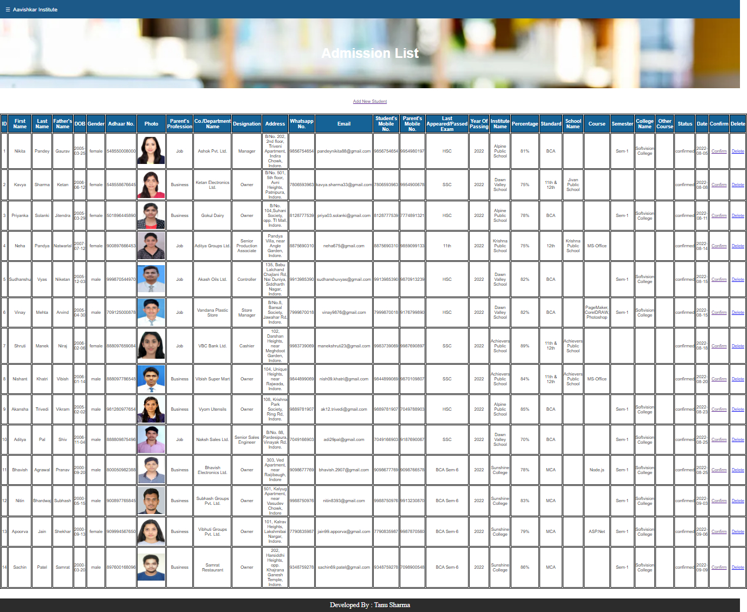or delete the admission.
2. 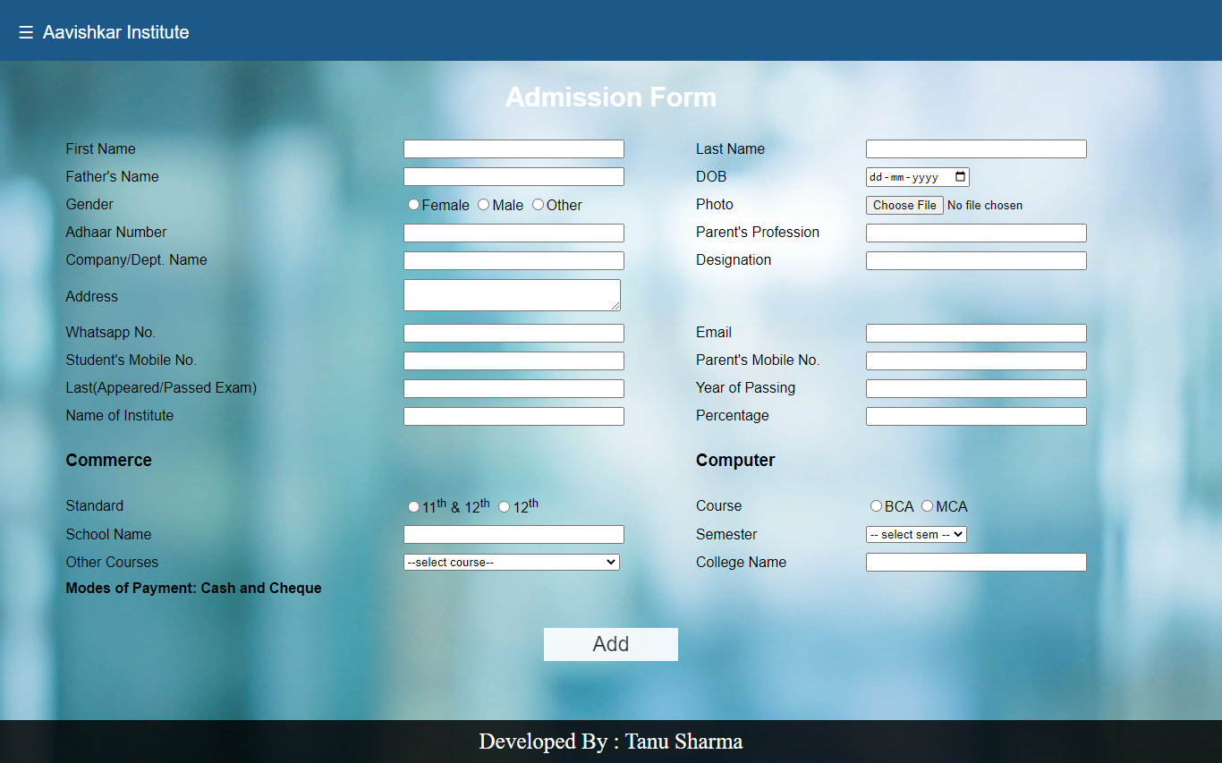Add New Student Page: By clicking on Add New Student an admission form is displayed where admin can add a new student.
3. Courses Page: Here admin can view, add or delete courses.

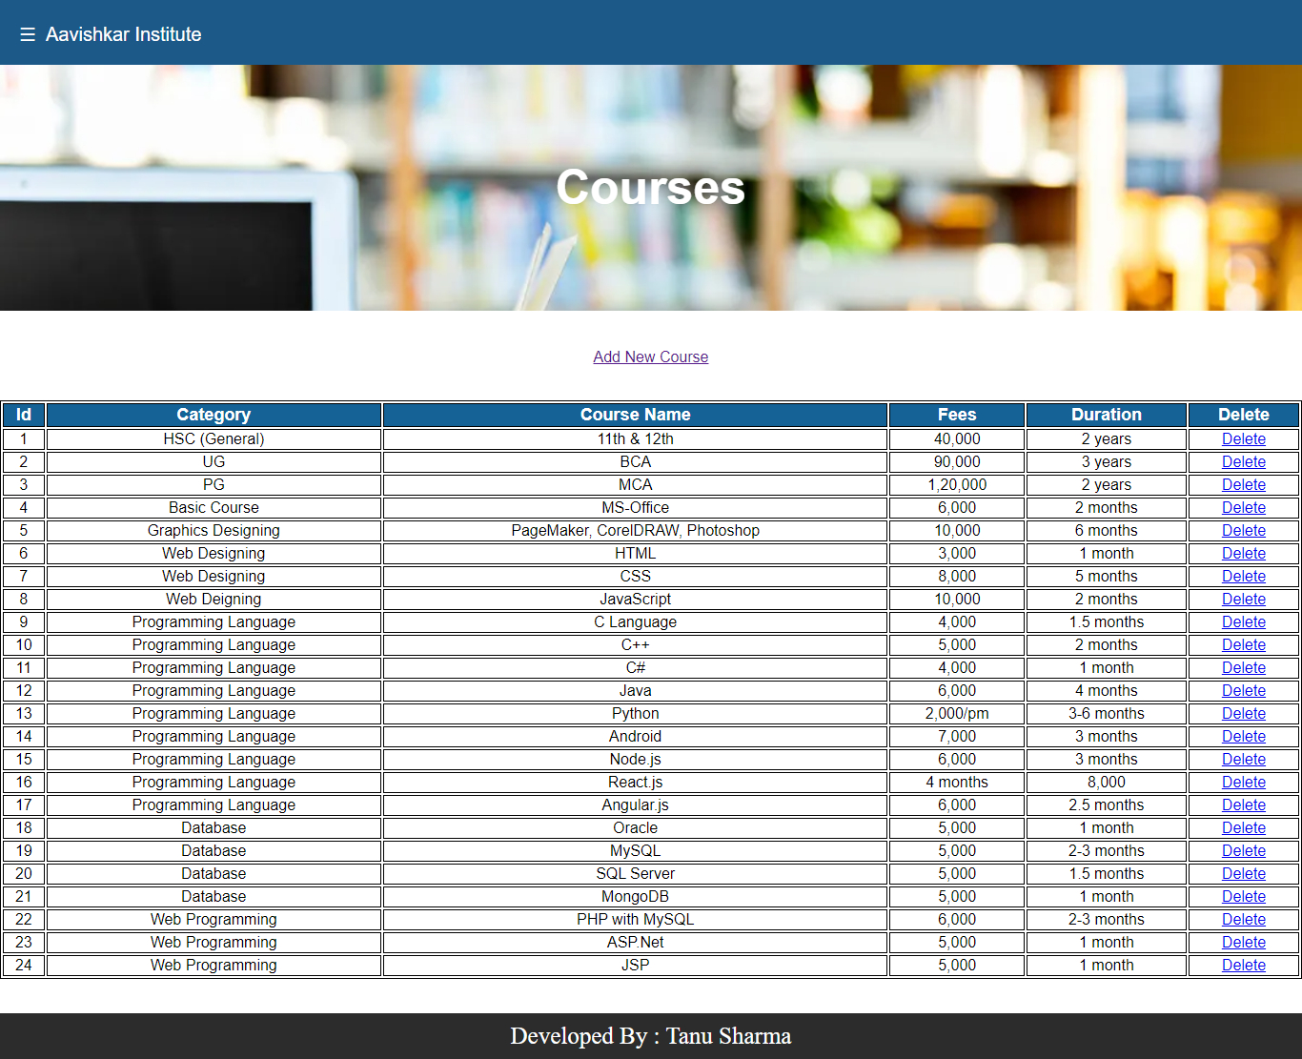

1. Add New Course Page: By clicking on Add New Course an add new course page is displayed where admin can add a new course.

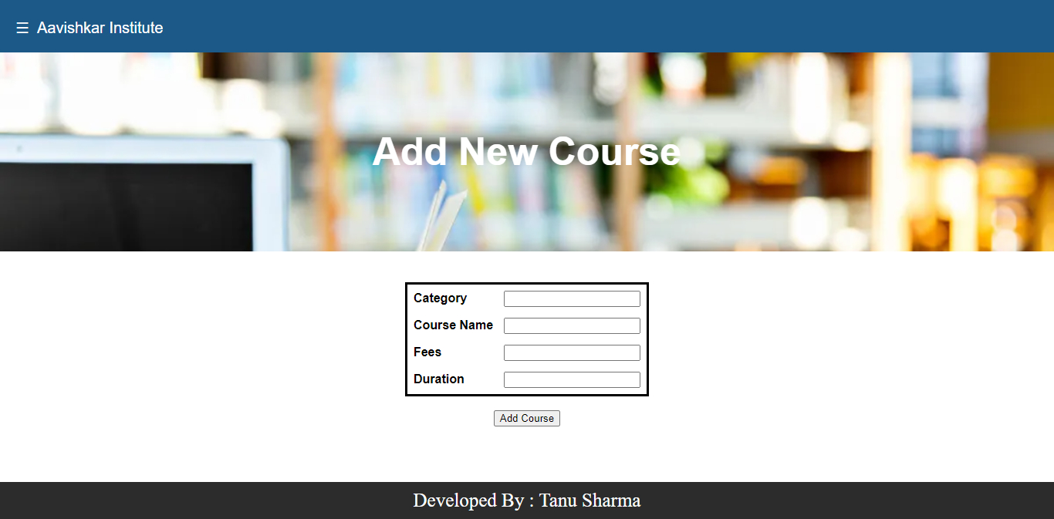

1. 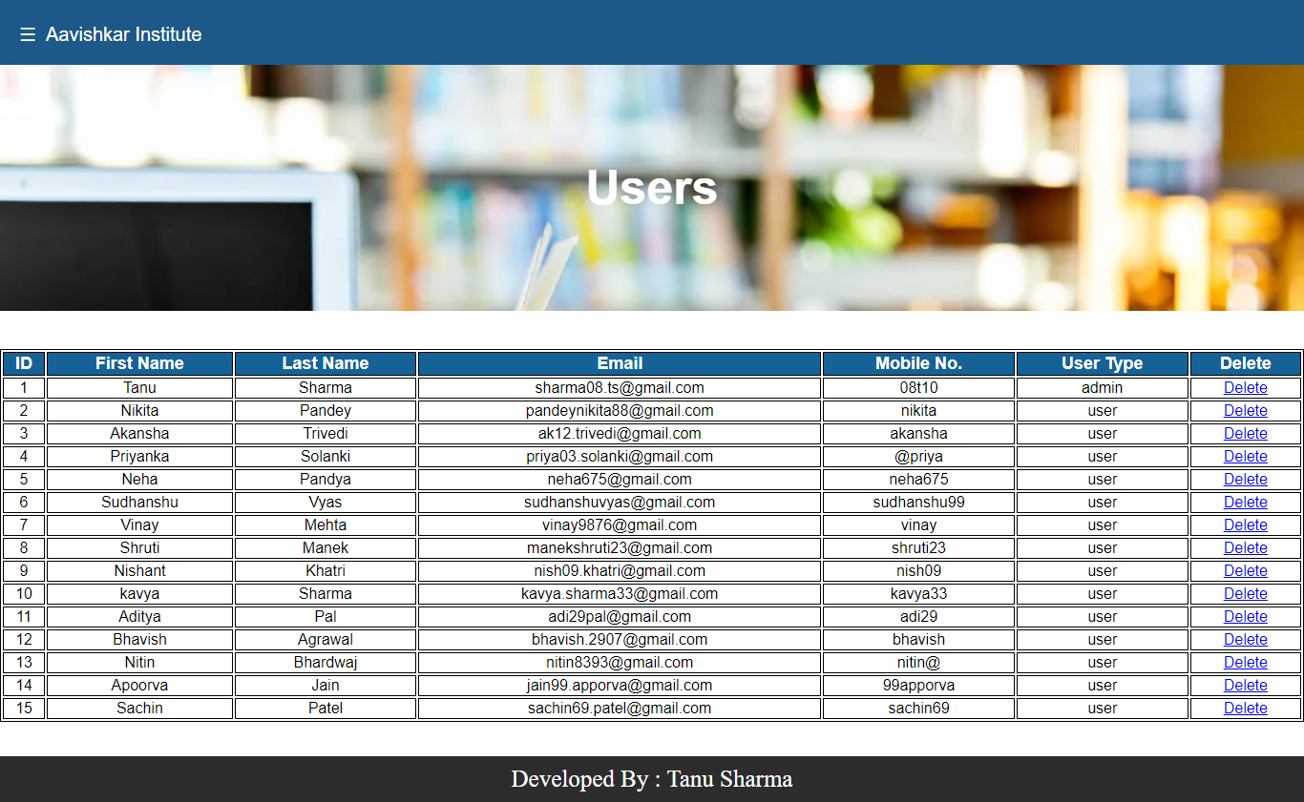Users Page: Here admin can view and delete users.
2. 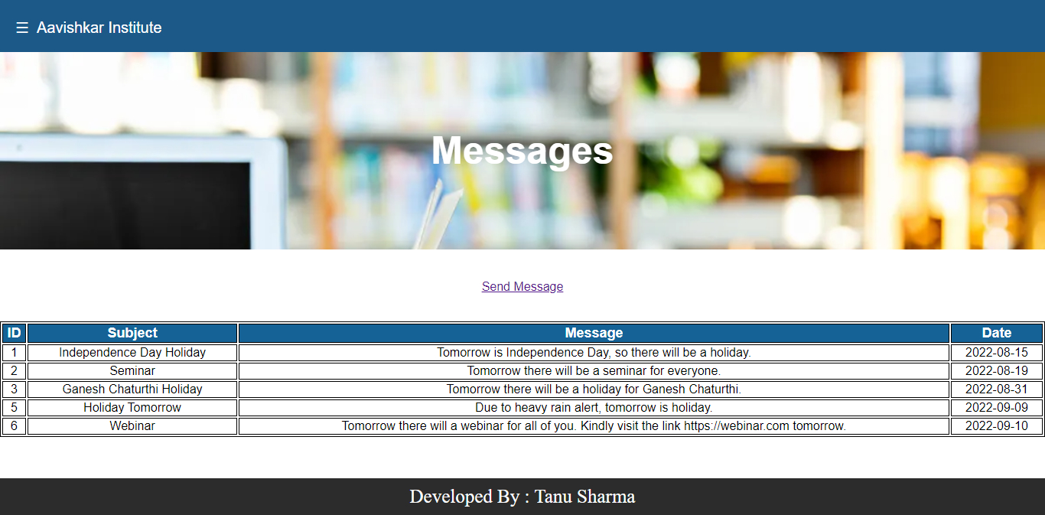­­­­Messages Page: Here all messages will be displayed that are sent by admin to user and also admin can send new messages.
3. 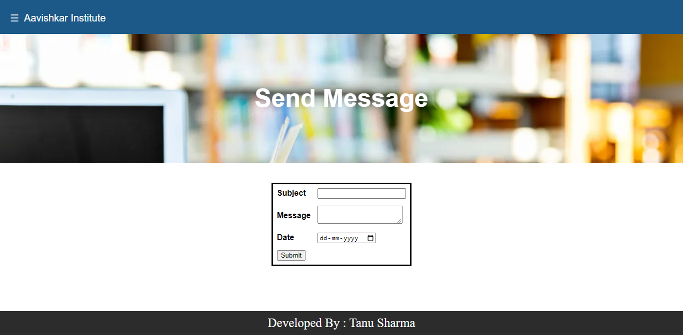Send Message Page: Here admin can send messages to users.
4. 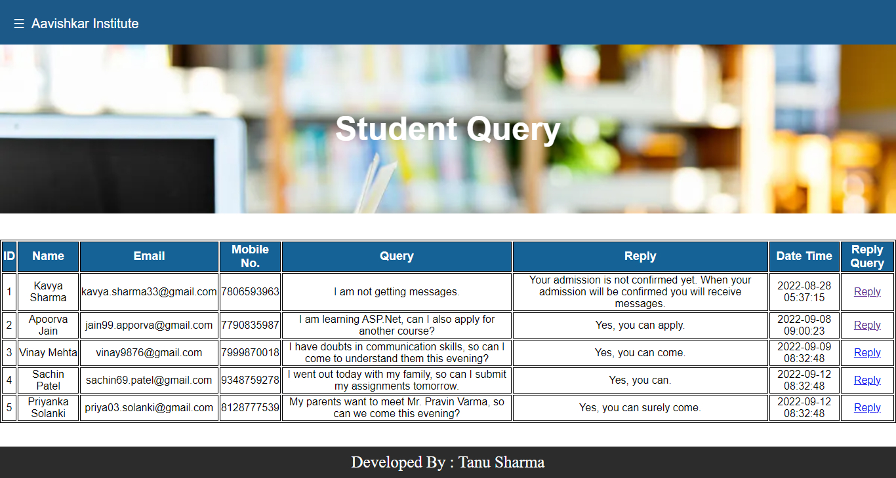Student Query Page: Here admin can view queries asked by students and can also reply to them.
5. 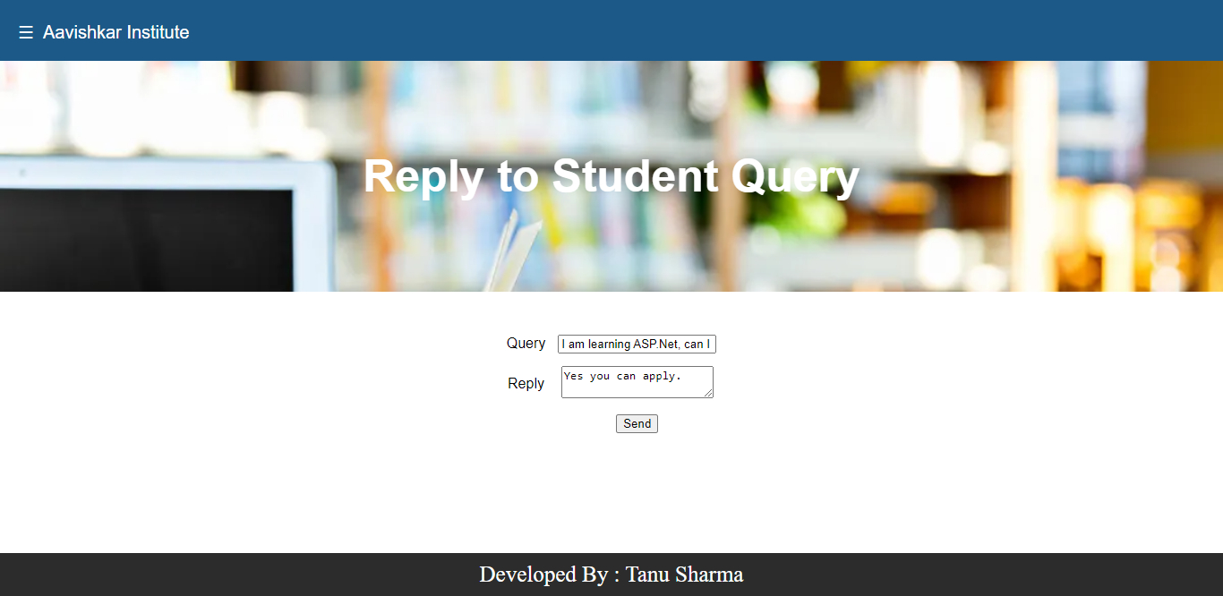Reply To Student Query Page: By clicking on reply a reply to student query page is displayed where admin can reply to student’s query.
6. 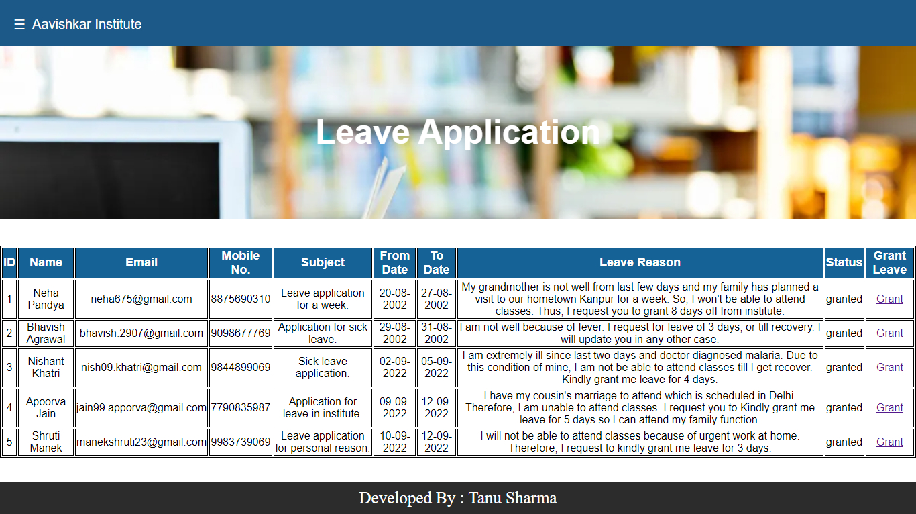Leave Application Page: Here admin can view all leave applications submitted by students and can grant them.
7. 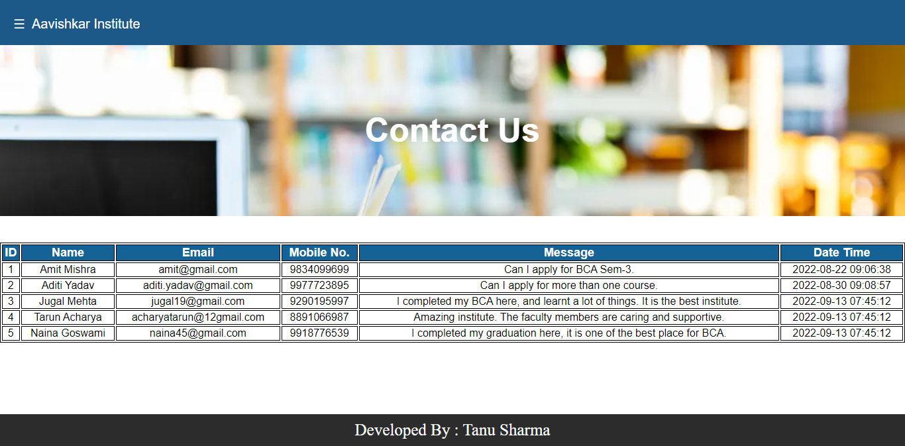Contact Us Page: Here admin can view contact us messages submitted by visitor.
8. 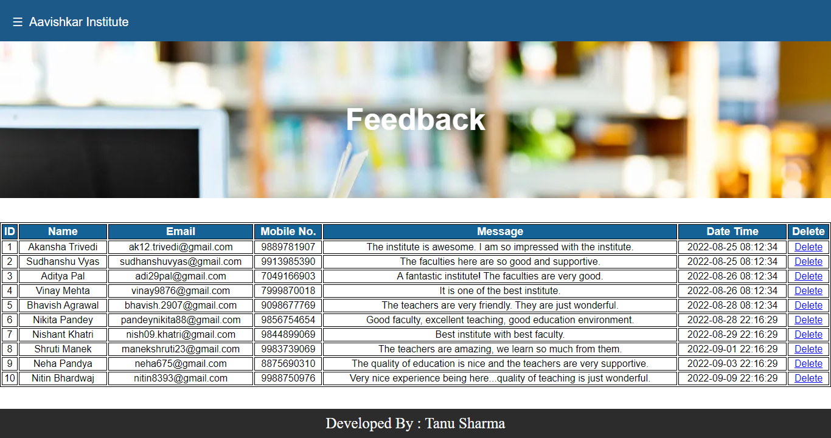Feedback Page: Here admin can view and delete feedbacks.
9. 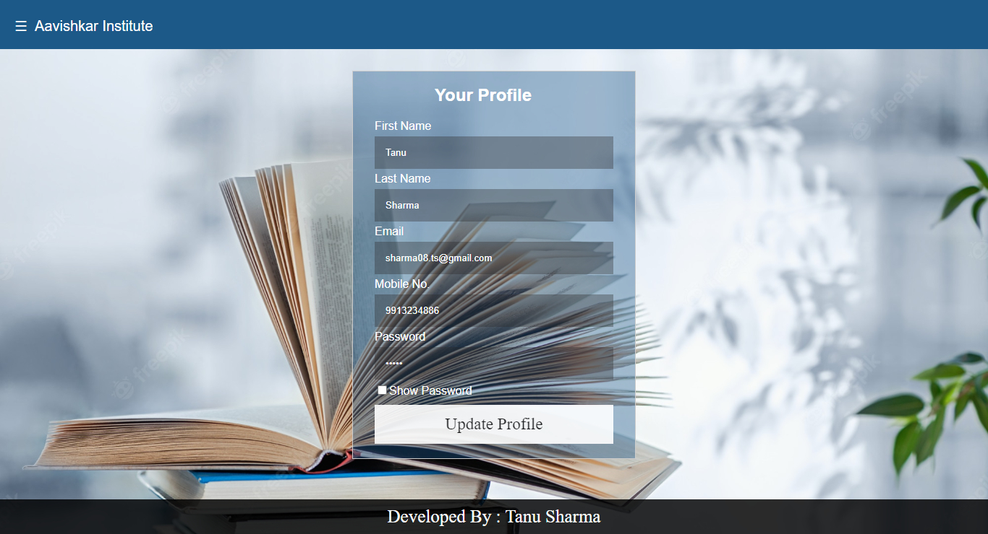Profile Page: Here admin can view and update his profile.
10. Change Password Page: Here admin can easily change password by providing required details.

4.6 Source Code

* Visitor Side Code:
* Connection String:
* $cn=mysqli_connect ("localhost", "root", "", "aavishkar_institute");

1. Sign Up File:

* $q=mysqli_query ($cn,"select mno from user_login where email='$email' or mno='$mno' or password='$password'");

if(mysqli_num_rows($q)! = 0)

{

echo "<script>alert ('The user already exists') </script>";

echo "<script>window.location='signup.php'</script>";

}

else

{

$q=mysqli_query ($cn, "insert into user_login (fnm, lnm, email, mno, password, usertype) values ('$fnm', '$lnm', '$email', '$mno', '$password', 'user')");

echo "<script>alert ('Registered as User...') </script>";

echo "<script>window.location='login.php'</script>";

}

1. Contact Us File:

* $q=mysqli_query ($cn, "insert into contactus (name, email, mno, message) values ('$name', '$email', '$mno', '$message')");
* User Side Code:

1. Login File:

* $login=$cn->query ("select * from user_login where mno='$mno' and password='$password'");

1. Forgot Password File:

* $q=mysqli_query ($cn, "select mno from user_login where email='$email' and mno='$mno'");

if(mysqli_num_rows($q)! =0)

{

$q=mysqli_query ($cn, "update user_login set password='$password' where mno='$mno'");

echo "<script>alert ('Your Password Updated Successfully...') </script>";

}

else

{

echo "<script>alert ('Please enter a valid email or mobile no. ....') </script>";

}

1. Admission File:

* $q=mysqli_query ($cn, "select adhaarno from admission where adhaarno='$adhaarno'");

if(mysqli_num_rows($q)! = 0)

{

echo "<script>alert ('The adhaar no. already exists') </script>";

echo "<script>window.location='admission.php' </script>";

}

else

{

$q=mysqli_query ($cn, "insert into admission (fnm, lnm, fathernm, dob, gender, adhaarno, photo, parentprof, codept, designation, address, whatsappno, email, studmno, pmno, lastexam, yrofpassing, instnm, pr, std, schoolnm, course, sem, collegenm, othercourse, status) values ('$fnm', '$lnm', '$fathernm', '$dob', '$gender', '$adhaarno', '$photo', '$parentprof', '$codept', '$designation', '$address', '$whatsappno', '$email', '$studmno', '$pmno', '$lastexam', '$yrofpassing', '$instnm', '$pr', '$std', '$schoolnm', '$course', '$sem', '$collegenm', '$othercourse', 'pending')");

move_uploaded_file($_FILES['photo']['tmp_name'],"../images/".$_FILES['photo']['name']);

echo "<script>alert ('Applied for admission successfully...’) </script>";

echo "<script> window.location='messages.php' </script>";

}

1. Courses File:

* $query = mysqli_query ($cn, "select * from courses");

1. Messages File:

* $query=mysqli_query ($cn, "select * from admission where studmno=$mno or pmno=$mno");
* $query=mysqli_query ($cn,"select * from messages");
* $query=mysqli_query ($cn,"select * from studquery where mno=$mno");
* $query=mysqli_query ($cn, "select * from lv_report where mno=$mno");

1. Student Query File:

* $q=mysqli_query ($cn, "insert into studquery (name, email, mno, query, reply) values ('$name', '$email', '$mno', '$query', 'pending')");

1. Leave Application File:

* $q=mysqli_query ($cn, "insert into lv_app (name, email, mno, subject, from_dt, to_dt, lv_reason, status) values ('$name', '$email', '$mno', '$subject', '$from_dt', '$to_dt', '$lv_reason','')");

1. Feedback File:

* $q=mysqli_query ($cn, "insert into feedback (name, email, mno, feedback) values ('$name', '$email', '$mno', '$feedback')");

1. Profile File:

* $query=mysqli_query ($cn, "select * from user_login where mno=$mno");

1. Update Profile File:

* $q=mysqli_query ($cn, "update user_login set fnm='$fnm', lnm='$lnm', email='$email', mno='$mno', password='$password' where mno='$mno'");

1. Change Password File:

* $q=mysqli_query ($cn, "select mno from user_login where mno='$mno' and password='$password1'");

if(mysqli_num_rows($q)! =0)

{

$q=mysqli_query ($cn, "update user_login set password='$password2' where mno='$mno'");

echo "<script>alert ('Your Password Updated Successfully...') </script>";

}

else

{

echo "<script>alert ('Please enter a valid email or mobile no. or password ....') </script>";

}

1. Logout File:

* session_start ();

if(isset($_SESSION['admin']))

{

session_unset ();

header ('location: ../index.php');

}

* Admin Side Code:

1. Admission List File:

* $query=mysqli_query ($cn, "select * from admission");

1. Confirm Admission File:

* $q=mysqli_query ($cn, "update admission set status='confirm' where id=$id");

1. Delete Student File:

* $q=mysqli_query ($cn, "delete from admission where id=$id");

1. Add New Student File:

* $q=mysqli_query ($cn, "select adhaarno from admission where adhaarno='$adhaarno'");

if(mysqli_num_rows($q)! = 0)

{

echo "<script>alert ('The adhaar no. already exists') </script>";

echo "<script>window.location='admission.php' </script>";

}

else

{

$q=mysqli_query ($cn, "insert into admission (fnm, lnm, fathernm, dob, gender, adhaarno, photo, parentprof, codept, designation, address, whatsappno, email, studmno, pmno, lastexam, yrofpassing, instnm, pr, std, schoolnm, course, sem, collegenm, othercourse, status) values ('$fnm', '$lnm', '$fathernm', '$dob', '$gender', '$adhaarno', '$photo', '$parentprof', '$codept', '$designation', '$address', '$whatsappno', '$email', '$studmno', '$pmno', '$lastexam', '$yrofpassing', '$instnm', '$pr', '$std', '$schoolnm', '$course', '$sem', '$collegenm', '$othercourse', 'pending')");

move_uploaded_file($_FILES['photo']['tmp_name'],"../images/".$_FILES['photo']['name']);

echo "<script>alert ('Applied for admission successfully...’) </script>";

echo "<script> window.location='messages.php' </script>";

}

1. Courses File:

* $query = mysqli_query ($cn, "select * from courses");

1. Add New Course File:

* $q=mysqli_query ($cn, "insert into courses (category, coursenm, fees, duration) values ('$category', '$coursenm', '$fees', '$duration')");

1. Delete Course File:

* $q=mysqli_query ($cn, "delete from courses where id=$id");

1. Users File:

* $query=mysqli_query ($cn, "select * from user_login");

1. Delete User File:

* $q=mysqli_query ($cn, "delete from user_login where id=$id");

1. Messages File:

* $query=mysqli_query ($cn, "select * from messages");

1. Send Message File:

* $q=mysqli_query ($cn, "insert into messages (std, subject, message, date) values ('$std', '$subject', '$message', '$date')");

1. Student Query File:

* $query=mysqli_query ($cn, "select * from studquery");

1. Reply Student Query File:

* $q=mysqli_query ($cn, "update studquery set reply='$reply' where id=$id");

1. Leave Application File:

* $query=mysqli_query ($cn, "select * from lv_app");

1. Grant Leave File:

* $q=mysqli_query ($cn, "update lv_app set status='granted' where id=$id");

1. Contact Us File:

* $query=mysqli_query ($cn, "select * from contactus");

1. Feedback File:

* $query=mysqli_query ($cn, "select * from feedback");

1. Delete Feedback File:

* $q=mysqli_query ($cn, "delete from feedback where id=$id");

1. Profile File:

* $query=mysqli_query ($cn, "select * from user_login where mno=$mno");

1. Update Profile File:

* $q=mysqli_query ($cn, "update user_login set fnm='$fnm', lnm='$lnm', email='$email', mno='$mno', password='$password' where mno='$mno'");

1. Change Password File:

* $q=mysqli_query ($cn, "select mno from user_login where mno='$mno' and password='$password1'");

if(mysqli_num_rows($q)! =0)

{

$q=mysqli_query ($cn, "update user_login set password='$password2' where mno='$mno'");

echo "<script>alert ('Your Password Updated Successfully...') </script>";

}

else

{

echo "<script>alert ('Please enter a valid email or mobile no. or password ....') </script>";

}

1. Logout File:

* session_start ();

if(isset($_SESSION['admin']))

{

session_unset ();

header ('location: ../index.php');

}

CHAPTER**:**5

Testing

5.1 Techniques and Strategies

5.2 Cost Estimation Model

5.3 Future Scope and Further Enhancement of the Project

5.4 Bibliography

5.5 Appendices

5.6 Glossary

5.1 Techniques and Strategies

Testing is a process to show the corrections of the program. Testing is needed to show completeness, to improve the quality of the software and to provide the maintenance aid. Some testing standards are therefore necessary reduce the testing costs and operation time.

Testing software extends throughout the coding phase and it represents the ultimate review of configurations, design and coding. Based on the way the software reacts to these testing.

We can decide whether the configuration that has been built is study or not. All components of an application are tested, as the failure to do so many results in a series of bugs after the software is put to use.

1. White Box Testing

White Box (or glass box) testing is the process of giving input to the system and checking how the system processes input to generate output.

It refers to the testing a system with full knowledge and access to all source code and other architecture documents. This testing enables to reveal bugs and vulnerabilities quickly in comparison with trial-and-error method. More complete testing coverage is ensured by exactly knowing what to test.

White box testing involves thorough testing of the application. It requires knowledge of code and the test cases chosen verifies if the system is implemented as expected. It typically includes checking with the data flow, exceptions, and errors, how they are handled, comparing if the code produces the expected results.

1. Black Box Testing

Black Box testing is the process of giving input to the system and checking the output of the system without bothering how the output is generated.

It refers to testing a system without knowledge of specification to the internal workings of the system, access to the source code, and knowledge of the architecture.

Essentially this approach mimics in a close approach, how an attacker typically follows approach to the application. However, the uncovering of issues or vulnerabilities could be further longer, because of lacking internal application knowledge.

Black box testing is done at an outer level of the system. Test cases merely check if the output is correct for the given input. User is not expected to the internal flow or design of the system.

1. Grey Box Testing

Grey Box testing is a combination of White Box and Glass Box Testing. In this, the tester has little knowledge about the internal working of the software. So, he tests the output as well as process carried out to generate the output.

It refers to a testing system by knowing limited information about the internals of the system. The knowledge is always limited for detailed design documents and architecture diagrams. In concise, it is a good blend of black and white box testing, which leverages the strengths of each of the testing.

Grey box testing is a combination of both black box and white box testing. This is because it involves access to the system; however, at an outer level. A little knowledge of the system is expected in grey box testing.

1. Non-Functional Testing

Non-functional testing is the testing of a software application or system for its non-functional Requirements: the way a system operates, rather than specific behaviors of that system.

This is contrast to functional testing, which tests against functional requirements that describe the functions of a system and its components.

The names of many non-functional tests are often used interchangeably because of the overlap in scope between various non-functional requirements. For example, software performance is a broad term that includes many specific requirements like reliability and scalability.

* Software Testing Strategies

Testing involves:

1. Unit Testing

The unit testing is purpose of unit testing is to ensure that each program is fully tested.

1. Integration Testing

The integration testing is individual program units or programs are integrated and tested as a complete system to ensure that the software requirements.

1. Acceptance Testing

This testing involves planning and the execution of various types of tests in order to demonstrate that the implemented software system satisfied the requirements.

Finally, our project meets the requirements after going through all the levels of testing.

5.2 Cost Estimation Model

* Costing Objectives
* To ensure viability
* Feasibility study
* Resource planning
* Cost/benefit analysis
* Provide input for pricing (including bidding negotiations etc.)
* To serve as a management tool
* Cost Control and Management
* Risk management
* Budget planning
* Criteria for good project coding
* Accurate
* Realistic (good procurement and engineering practice)
* Consistent
* Transparent
* Cost-effective
* Goof Documentation

Project Costing

Many looks upon project testing as a cost. While it is true that software testing does cost money, in many cases significant amounts of money, it is also an activity that an organization to avoid costly failures further on in the development process.

Most understand this relationship project testing is spending money to save money. What many do not also realize is that software testing also produces valuable assets for the organization. This article will discuss those assets of software testing.

* Cost Estimation
* Working time estimation is given below:

3 months = 90 days

5 hrs / day = 450 hours

* Now, the expenses & cost estimation are given below:

Computer rent = 6,000 /-

+ Light Bill Rs. 5 / unit (worth 400 units) = 4,000 /-

+ Database design & creation = 1,500 /-

+ Coding & Validation = 2,500 /-

Total = 14,000 /-

SDLC Model

* Waterfall Model

Waterfall approach was first SDLC Model to be used widely in

Software Engineering to ensure success of the project. In "The Waterfall" approach, the whole process of software development is divided into separate phases. In Waterfall model, typically, the outcome of one phase acts as the input for the next phase sequentially. Following is a diagrammatic representation of different phases of waterfall model.

Requirements Analysis

System Design

Implementation

Testing

Maintenance

Deployment

* Iterative Model

In Iterative model, iterative process starts with a simple implementation of a small set of the software requirements and iteratively enhances the evolving versions until the complete system is implemented and ready to be deployed. An iterative life cycle model does not attempt to start with a full specification of requirements. Instead, development begins by specifying and implementing just part of the software, which is then reviewed in order to identify further requirements. This process is then repeated, producing a new version of the software at the end of each iteration of the model.

Build 1

Build 2

Build 3

Requirements

Design & Development

Implementation

Testing

Design & Development

Implementation

Testing

Design & Development

Implementation

Testing

* V-Model

The V-Model is SDLC model where execution of processes Verification happens in a sequential manner in V-shape. It is also known as Verification and Validation model. V - Model is an extension of the

waterfall model and is based on association of a testing phase for each corresponding development stage. This means that for every single phase in the development cycle there is a directly associated testing phase. This is a highly disciplined model and next phase starts only after completion of the previous phase.

* V-Model Design

Under V-Model, the corresponding testing phase of the

development phase is planned in parallel. So, there are Verification phases on one side of the V-Model and Validation phases on the other side. Coding phase joins the two sides of the V-Model. The below figure illustrates the different phases in V-Model of SDLC.

Verification Validation

Requirement Gathering

System Design

Architecture Design

Module Design

Coding

Unit Testing

Integration Testing

System Testing

Acceptance Testing

Acceptance Test Design

System Test Design

Integration Test Design

Unit Test Design

* Spiral Model

The spiral model combines the idea of iterative development with the systematic, controlled aspects of the waterfall model. Spiral model is a combination of iterative development process model and sequential linear development model i.e., waterfall model with very high emphasis on risk analysis. It allows for incremental releases of the product, or incremental refinement through each iteration around the spiral.

* Spiral Model Design

The spiral model has four phases. A software project repeatedly passes through these phases in iterations called Spirals.

* Identification:

This phase starts with gathering the business requirements in the baseline spiral. In the subsequent spirals as the product matures, identification of system requirements, subsystem requirements and unit requirements are all done in.

This phase This also includes understanding the system requirements by continuous communication between the customer and the system analyst. At the end of the spiral the product is deployed in the identified market.

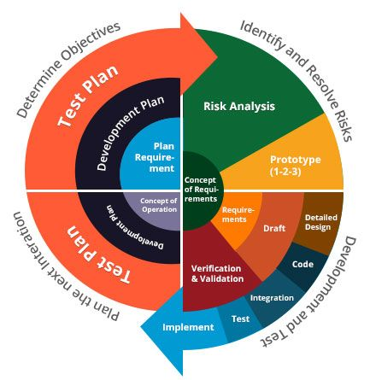

* Prototype Model

The basic idea here is that instead of freezing the requirements before a design or coding can proceed, a throwaway prototype is built to understand the requirements. This prototype is developed based on the currently known requirements. By using this prototype, the client can get an “actual feel” of the system, since the interactions with prototype can enable the client to better understand the requirements of the desired system. Prototyping is an attractive idea for complicated and large systems for which there is no manual process or existing system to help determining the requirements. The prototype is usually not complete systems and many of the details are not built in the prototype. The goal is to provide a system with overall functionality.

Requirement Gathering

Quick Design

Building Prototype

Engineer Product

Refining Prototype

Customer Evaluation

Start

Stop

5.3 Future Enhancements

A good project is one which never stops developing according to the changing situations and technologies there is a lot of scope of future enhancements.

* Online Payment.
* Online Teaching.
* Student Attendance.
* Online Exams.
* New User To-Do List.
* Online study material for students.

5.4 Bibliography

For the successful working of my project, I have referred many sources for the code snippets, logic and tips and tricks from the various books as well as web sites. Most I searched for the required possessions on the google.com search engine.

* Web Link:

1. google.com
2. w3schools.com

5.5 Appendices

The project Aavishkar Institute is the customize working on Admission of students.

The software takes care of all requirement and helps to the students for taking admission.

We have successfully designed, coded and implemented our project with a lot of Hard work.

Finally, I would like to thank our project guide Dr. Neha K. Shah for giving helpful guidelines for our project and also for giving suggestions when difficulties raised in our project.

5.6 Glossary

ANSI : American National Standards Institute

CSS : Cascading Style Sheets

DFD : Data Flow Diagram

ERD : Entity Relationship Diagram

GPL : GNU General Public License

GUI : Graphical User Interface

HTML : Hyper Text Markup Language

ISO : International Organization for Standardization

JS : JavaScript

MySQL : My Structured Query Language

NF : Normal Form

PERT : Program Evaluation Review Technique

PHP : Hypertext Preprocessor

SDLC : Software Development Life Cycle

SRS : Software Requirements Specification

SVG : Scalable Vector Graphics

W3C : World Wide Web Consortium

XHTML : Extensible Hyper Text Markup Language

XML : Extensible Markup Language

XUL : Extensible User Interface Language

Thank You